**Glaucoma**

**Definition**: Glaucoma is a common eye condition where the optic nerve, which connects the eye to the brain, becomes damaged. It's usually caused by fluid building up in the front part of the eye, which increases pressure inside the eye. Glaucoma can lead to loss of vision if it's not diagnosed and treated early.

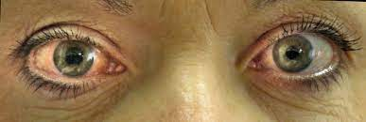

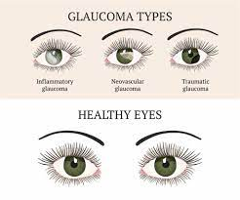

**Types:**

There are several types of glaucoma. The two main types are open-angle and angle-closure. These are marked by an increase of intraocular pressure (IOP), or pressure inside the eye.

**open-angle:**

open-angle glaucoma, the most common form of glaucoma, accounting for at least 90% of all glaucoma cases.

* Is caused by the slow clogging of the drainage canals, resulting in increased eye pressure
* Has a wide and open angle between the iris and cornea
* Develops slowly and is a lifelong condition
* Has symptoms and damage that are not noticed.

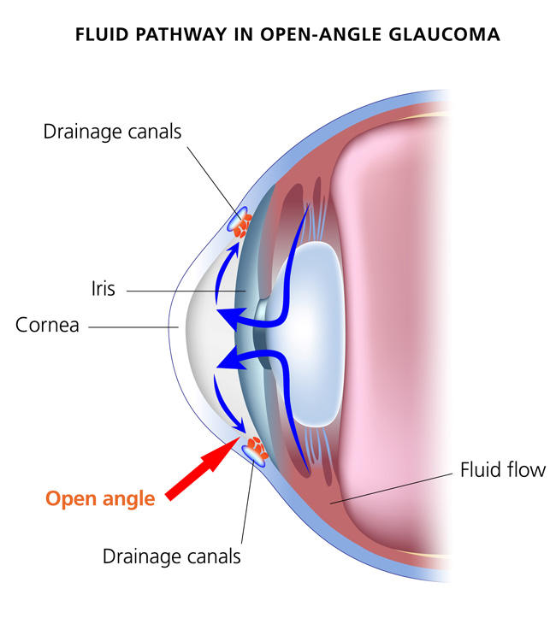

**Angle-Closure Glaucoma:**

Angle-closure glaucoma, a less common form of glaucoma:

* Is caused by blocked drainage canals, resulting in a sudden rise in intraocular pressure
* Has a closed or narrow angle between the iris and cornea
* Develops very quickly
* Has symptoms and damage that are usually very noticeable
* Demands immediate medical attention.

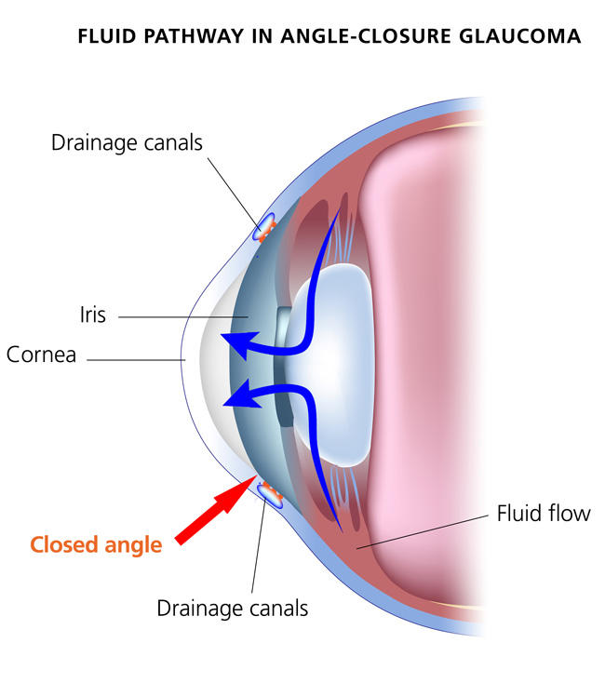

**Normal-Tension Glaucoma (NTG)**

Also called low-tension or normal-pressure glaucoma. In normal-tension glaucoma the optic nerve is damaged even though the eye pressure is not very high. We still don't know why some people’s optic nerves are damaged even though they have almost normal pressure levels.

**Congenital Glaucoma**

This type of glaucoma occurs in babies when there is incorrect or incomplete development of the eye's drainage canals during the prenatal period. This is a rare condition that may be inherited. When uncomplicated, microsurgery can often correct the structural defects. Other cases are treated with medication and surgery.

**Other Types of Glaucoma**

Variants of open-angle and angle-closure glaucoma include:

* [Secondary Glaucoma](https://www.glaucoma.org/glaucoma/secondary-glaucoma.php)
* [Pigmentary Glaucoma](https://www.glaucoma.org/glaucoma/pigment-dispersion-syndrome-and-pigmentary-glaucoma.php)
* [Pseudo exfoliative Glaucoma](https://www.glaucoma.org/glaucoma/exfoliative-glaucoma.php)
* [Traumatic Glaucoma](https://www.glaucoma.org/glaucoma/traumatic-glaucoma.php)
* Neovascular Glaucoma
* [Irido Corneal Endothelial Syndrome](https://www.glaucoma.org/q-a/what-is-irido-corneal-endothelial-syndrome-ice.php) (ICE)
* [Uveitic Glaucoma](https://www.glaucoma.org/glaucoma/understanding-uveitic-glaucoma.php)

**Causes:**

Several things can cause high eye pressure and glaucoma:

* Family history of glaucoma
* Hereditary predisposition to glaucoma
* Underlying conditions like diabetes or high blood pressure
* Regular use of certain medications, including steroids
* [Eye injury](https://www.allaboutvision.com/conditions/eye-injuries.htm) or trauma
* Thin corneas (the clear layer in front of your pupils)
* Extreme [nearsightedness](https://www.allaboutvision.com/conditions/myopia.htm) or [farsightedness](https://www.allaboutvision.com/conditions/hyperopia.htm)
* Being over age 60

**Pathophysiology:** The main problem or pathology in glaucoma is caused by raised intraocular pressure. It is this raised pressure that compresses and damages the optic nerve. Once the optic nerve is damaged, it fails to carry visual information to the brain and this results in loss of vision.

**Risk factors**

Because chronic forms of glaucoma can destroy vision before any signs or symptoms are apparent, be aware of these risk factors:

* Having high internal eye pressure (intraocular pressure)
* Being over age 60
* Being black, Asian or Hispanic
* Having a family history of glaucoma
* Having certain medical conditions, such as diabetes, heart disease, high blood pressure and sickle cell anemia
* Having corneas that are thin in the center
* Being extremely nearsighted or farsighted
* Having had an eye injury or certain types of eye surgery
* Taking corticosteroid medications, especially eyedrops, for a long time

**Investigations:**

* Tonometry.
* Pupil Dilation
* Visual Field Testing
* Visual Acuity Test
* Pachymetry
* Ophthalmoscopy
* Gonioscopy
* Optic Nerve Imaging

**Prevention**

These self-care steps can help you detect glaucoma in its early stages, which is important in preventing vision loss or slowing its progress.

* **Get regular dilated eye examinations.** Regular comprehensive eye exams can help detect glaucoma in its early stages, before significant damage occurs. As a general rule, it is recommended having a comprehensive eye exam every five to 10 years if you're under 40 years old; every two to four years if you're 40 to 54 years old; every one to three years if you're 55 to 64 years old; and every one to two years if you're older than 65. If you're at risk of glaucoma, you'll need more frequent screening. Ask your doctor to recommend the right screening schedule for you.
* **Know your family's eye health history.** Glaucoma tends to run in families. If you're at increased risk, you may need more frequent screening.
* **Exercise safely.** Regular, moderate exercise may help prevent glaucoma by reducing eye pressure.
* **Take prescribed eyedrops regularly.** Glaucoma eyedrops can significantly reduce the risk that high eye pressure will progress to glaucoma. To be effective, eyedrops prescribed by your doctor need to be used regularly even if you have no symptoms.
* **Wear eye protection.** Serious eye injuries can lead to glaucoma. Wear eye protection when using power tools or playing high-speed racket sports in enclosed courts.

**Clinical Features:**

* intense eye pain
* nausea and vomiting
* a [red eye](https://www.nhs.uk/conditions/red-eye/)
* a [headache](https://www.nhs.uk/conditions/headaches/)
* tenderness around the eyes
* seeing rings around lights
* blurred vision

The signs and symptoms of glaucoma vary depending on the type and stage of your condition. For example:

**Open-angle glaucoma**

* Patchy blind spots in your side (peripheral) or central vision, frequently in both eyes
* Tunnel vision in the advanced stages

**Acute angle-closure glaucoma**

* Severe headache
* Eye pain
* Nausea and vomiting
* Blurred vision
* Halos around lights
* Eye redness

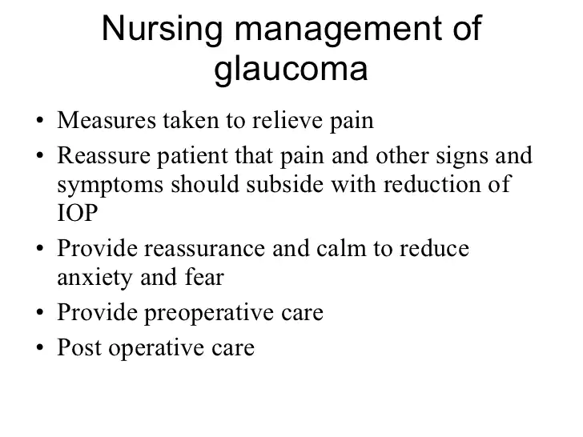

**Complications:**

Childhood glaucoma can cause:

* Sensitivity to light
* Gray hazy cornea
* Enlarged eye (can be noticeable in a photo before the condition is diagnosed)
* Excessive tearing
* Loss of vision

Symptoms of congenital (from birth) glaucoma may be noticeable as early as when a child is 1 month of age.

Classic signs of congenital glaucoma:

* Blinking
* Tearing
* Avoiding light

Potential complications:

* Chronic corneal [edema](https://www.healthgrades.com/right-care/symptoms-and-conditions/edema) (loss of transparency)
* Loss of central or side (peripheral) vision
* Loss of vision or changes in vision

**Created by:**

**Rana Singha**

**Lecturer**

**Companiganj Upazilla Health Complex**